***DSA LAB 5***

***Roll number =cs2020f-cs-030***

***Name=Syed obaid hashmi***

***TASK #4***

*#include <iostream>*

*using namespace std;*

*int main()*

*{*

*int array[10];*

*int i=0, j=0,temp=0,swap=0,comparisons=0;*

*cout<<"enter 10 number in array\n";*

*for(i = 0 ;i<10;i++)*

*{*

*cin>>array[i];*

*}*

*cout << "array before sorting " << endl;*

*for ( i = 0; i < 10; i++)*

*{*

*cout << array[i] << " ";*

*}*

*for (int i = 0; i < 10; i++)*

*{//bubble sort*

*for (int j = i + 1; j < 10; j++)*

*{*

*comparisons++;*

*if (array[j] < array[i]) {*

*temp = array[i];*

*array[i] = array[j];*

*array[j] = temp;*

*swap++;*

*}*

*}*

*}*

*cout << endl << "array after sorting " << endl;*

*for (i = 0; i < 10; i++)*

*{*

*cout << array[i] << " ";*

*}*

*cout << endl << "number of swaps are " << swap;*

*cout << endl << "number of comparisons are " << comparisons;*

*return 0;*

*}*

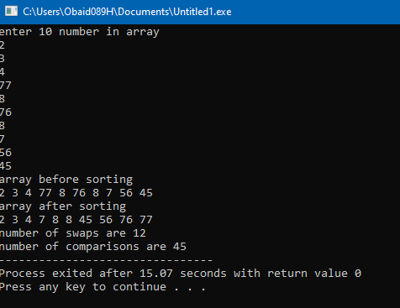

***TASK #5***

*#include<iostream>*

*using namespace std;*

*void swapping(int &a, int &b) { //swap the content of a and b*

*int temp;*

*temp = a;*

*a = b;*

*b = temp;*

*}*

*void display(int *array, int size) {*

*for(int i = 0; i<size; i++)*

*cout << array[i] << " ";*

*cout << endl;*

*}*

*void selectionSort(int *array, int size) {*

*int i, j, imin;*

*for(i = 0; i<size-1; i++) {*

*imin = i; //get index of minimum data*

*for(j = i+1; j<size; j++)*

*if(array[j] < array[imin])*

*imin = j;*

*//placing in correct position*

*swap(array[i], array[imin]);*

*}*

*}*

*int main() {*

*int n;*

*cout << "Enter the number of elements: ";*

*cin >> n;*

*int arr[n]; //create an array with given number of elements*

*cout << "Enter elements:" << endl;*

*for(int i = 0; i<n; i++) {*

*cin >> arr[i];*

*}*

*cout << "Array before Sorting: ";*

*display(arr, n);*

*selectionSort(arr, n);*

*cout << "Array after Sorting: ";*

*display(arr, n);*

*}*

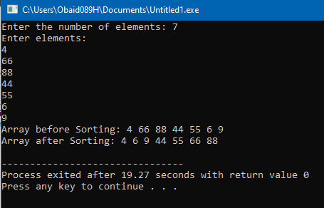

***TASK #6***

*#include <iostream>*

*using namespace std;*

*int main()*

*{*

*int array[8];*

*int i=0, j=0,temp=0,swaps=0,comparisons=0;*

*cout<<"enter 8 number in array\n";*

*for(i = 0 ;i<8;i++)*

*{*

*cin>>array[i];*

*}*

*cout << "array before sorting " << endl;*

*for ( i = 0; i < 8; i++)*

*{*

*cout << array[i] << " ";*

*}*

*for (int i=1 ; i < 8; i++)*

*{*

*temp = array[i];*

*j = i - 1;*

*while (j >= 0 && array[j]>temp)*

*{*

*array[j + 1] = array[j];*

*j--;*

*swaps++;*

*}*

*array[j + 1] = temp;*

*comparisons += i;*

*}*

*cout << endl << "array after sorting " << endl;*

*for (int i = 0; i < 8; i++)*

*{*

*cout << array[i] << " ";*

*}*

*cout << endl << "number of swaps are " << swaps;*

*cout << endl << "number of comparisons are " << comparisons;*

*return 0;*

*}*

